Welcome to BBC Classifieds
March 2025

Page 1 of 5
Baked goods and preserves
Callie's Homemade Baked Goods
Part of every sale goes to tumornators for brain cancer research. Contact for selection and prices.
Callie Williams: (919)475-4156
email: callienwilliams@gmail.com

Computer Sales, Repairs, Upgrade
Red Mountain Laptops
Windows based laptops repair, upgrades or refurbished laptop sales.
Scott Hodges: (919) 260-5280;
Website: redmountainlaptops.com
email: RedMountainLaptops@gmail.com

Childcare
Evening/weekend child care available
Becky Sheuneman: (919) 627-4657

Serenity and Felicity Brown
Contact Jenna: (919) 368-6368

April Glenning/Randy Wagner Co-Editors
(919) 471-3181/info@BahamaBaptistChurch.org

Construction/Remodeling
Jack Williams Construction
Deck work, Repairs, Remodeling, new construction, punch lists. Jack Williams: (919) 259-2405
email: jackman4him@gmail.com

Cutlery Sales
Rada Cutlery
The highest quality kitchen knives, cooking utensils, cutlery gift sets plus so much more. Ask for a catalog or go online to www.radacutlery.com and select shop then email, text, or tell me the item numbers you would like to purchase. I will reply with your purchase total, payment options and delivery details.
Bonnie Capps: (919) 384-5625
Email: bonniecapps59@yahoo.com

Farm to Table
Sweet T Farm
Delicious healthy pasture raised pork and lamb and 100% grass fed beef grown with love.
Travis and Christine Tankersley: (919) 949-4729
Website: www.sweettfarmnc.com
Email: sweettfarmnc@gmail.com
Page 2 of 5

Flower Arrangements
Wild Aster Farm
Dried flower arrangements.
Melissa English: (919) 810-2401
website: wildasterfarm.com
email: Info@wildasterfarm.com

Furniture/Woodworking
Holdfast Concepts & Design
Custom furniture, build, design, and rehab
Johnnathan Williams: (918) 619-3940;
email: holdfastcompany@gmail.com

Health/Wellness
Wild Aster Farm
Dried or fresh medicinal & culinary herbs, seedlings, herbal products, dried flowers(bulk).
Melissa English: (919) 810-2401
website: wildasterfarm.com
email: Info@wildasterfarm.com

Home Maintenance
Jack Williams Construction
Plumbing, electrical, home maintenance.
Jack Williams: (919) 259-2405
email: jackman4him@gmail.com

House Helper or Companion
For Widows, Elderly, Mothers of Small Children (or anyone): If you are in need of someone to do some light housework, play chess, read, or company, please contact the Brown Family: (919) 368-6368

Knife Making
Holdfast Concepts & Design
Knife making, woodworking and metal fabrication.
Johnnathan Williams: (918) 619-3940
email: holdfastcompany@gmail.com

Lawn and landscape
CAROLINA SCAPES, LLC LANDSCAPING SERVICES
Lawn maintenance, irrigation work, landscape, lighting, drainage work, patios, outdoor kitchens, firepits, all hardscape needs, landscape design.
Cody Johnson: (919) 698-9769
Rick Johnson: (919) 730-0501

Lawn Mowers/Equipment/Small Engine Services
Ellis Mowers
Quality mowers and other lawn equipment and
small engine repair at affordable prices.
Casey Ellis: (919) 323-1203
Website: ellismowers.com
email: ellis@ellismowers.com

Page 3 of 5

Mechanic

Contact Jordan Bell: (302)333-7382
email: bell.j9897@gmail.com

Notary
Please give at least 24 hours notice.
Teri Harris: (919) 949-2060

Pest Control
House Exterminators
Pest control, termites, mosquitos. We will make your home bug free.
Ricky Duke: (919) 906-9937
Website: HouseExterminators.com
email: HouseExterminators@gmail.com

Pet Sitting
Jathan Brown
Contact Jenna: (919) 368-6368

Callie's pet sitting
Contact Callie: (919) 475-2197
email: callienwilliams@gmail.com

Roofing
A&R Roofing
Jeremy White: (919) 809-0438
website: arroofingnc.com
email: Jeremy.ARRoofing@gmail.com

Sewing & Seamstress work
Garment creation, mending, alterations, and quilting. Becky Sheuneman: (919) 627-4657

Wedding and Event Design
Stephanie Garrett AIFD, NCCPF,CFD
Wedding and event design plus workshop curator
Stephanie Garrett: (919) 691-2537
Website: www.stephaniegarrettaifd.com
email: garrettst1971@gmail.com

Items For Sale

Septic Pump Injection System- Complete system is only 4 years old. Asking $800 or best offer
Contact Jack Williams: (919) 259-2405

Page 4 of 5

Items For Sale Continued
Quality Cotton Hang Towels-Use in your kitchen, bathroom, or even baby’s changing table. Thick 100% Cotton Full size (16” x 28”) hand towels folded over and crocheted to hang from a knob, towel ring, rod, or door handle. Makes a thoughtful gift! $5.00 each or 2 for $9.
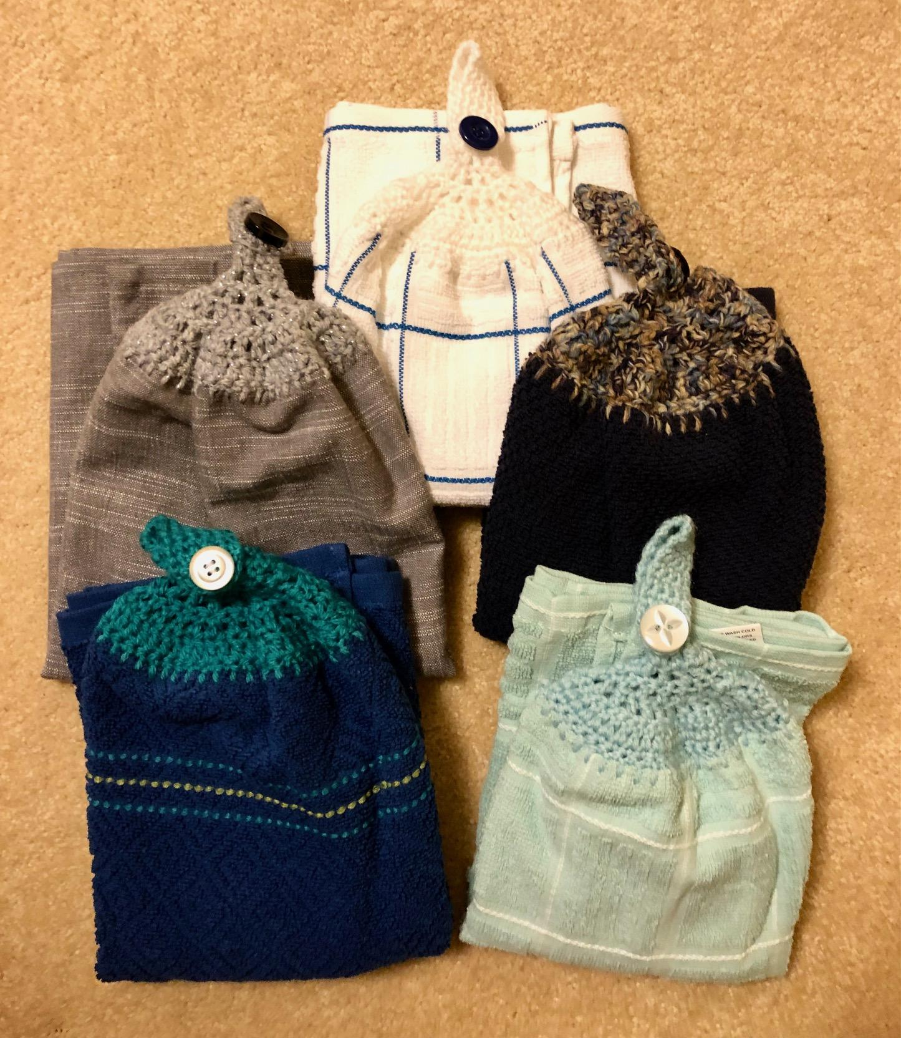
Gift Set: Three quality, 16” x 26” terry backed, 100% cotton, hand crocheted Hang Towels, fastened with beautiful Abalone buttons. These would be a perfect shower, birthday, or hostess gift. Only $15 for the set.
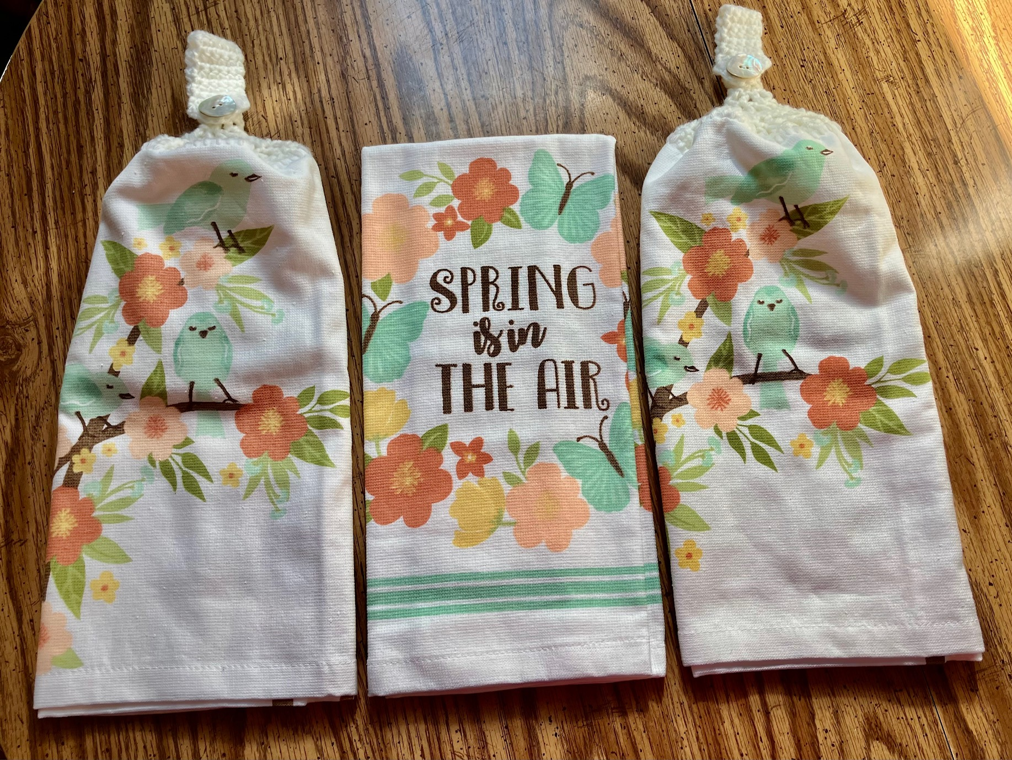

Oversized, 20 X 31, 100% cotton towels. Two for $10 or $5.50 each. Black and white striped towels can come as a set of 1 Hang towels and 1 regular flat towel, or 2 or more hang towels. Grey Linen look hang towels as a single or multiple for more than one place to hang them.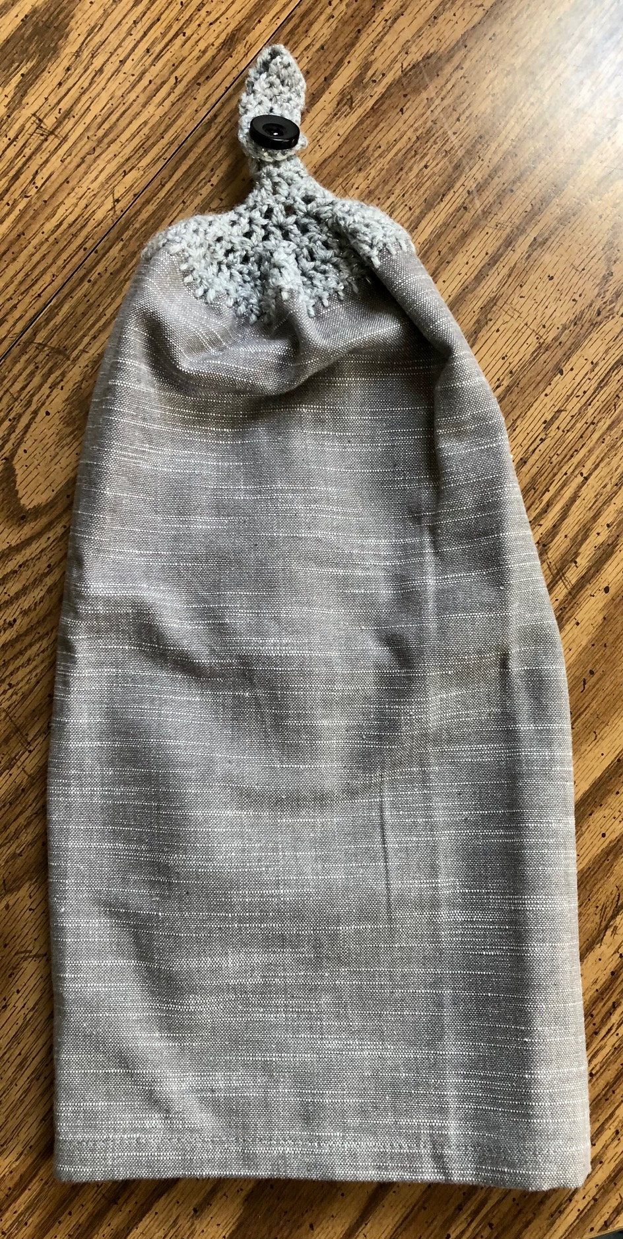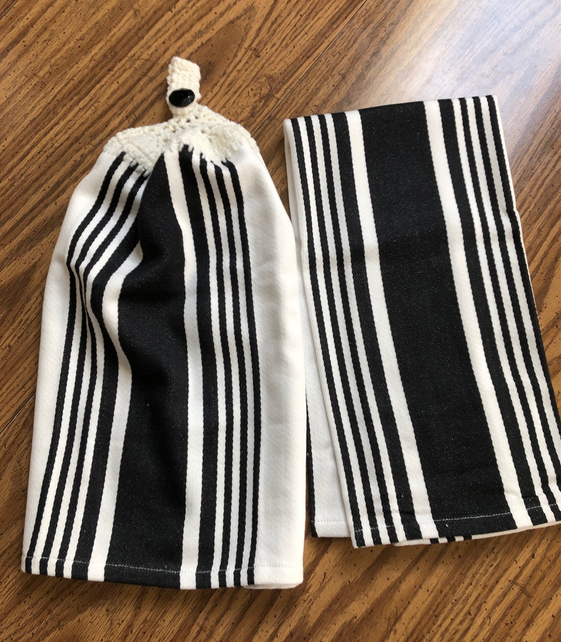
Spring Novelty hang towels: seasonal towels folded over and crocheted with a buttoned loop to enable hanging from a knob or handle. Decorate your kitchen or bathroom for spring. $3.75 each or 2 for $7.
Randy Wagner: (614) 581-3054
email: sunrands@gmail.com
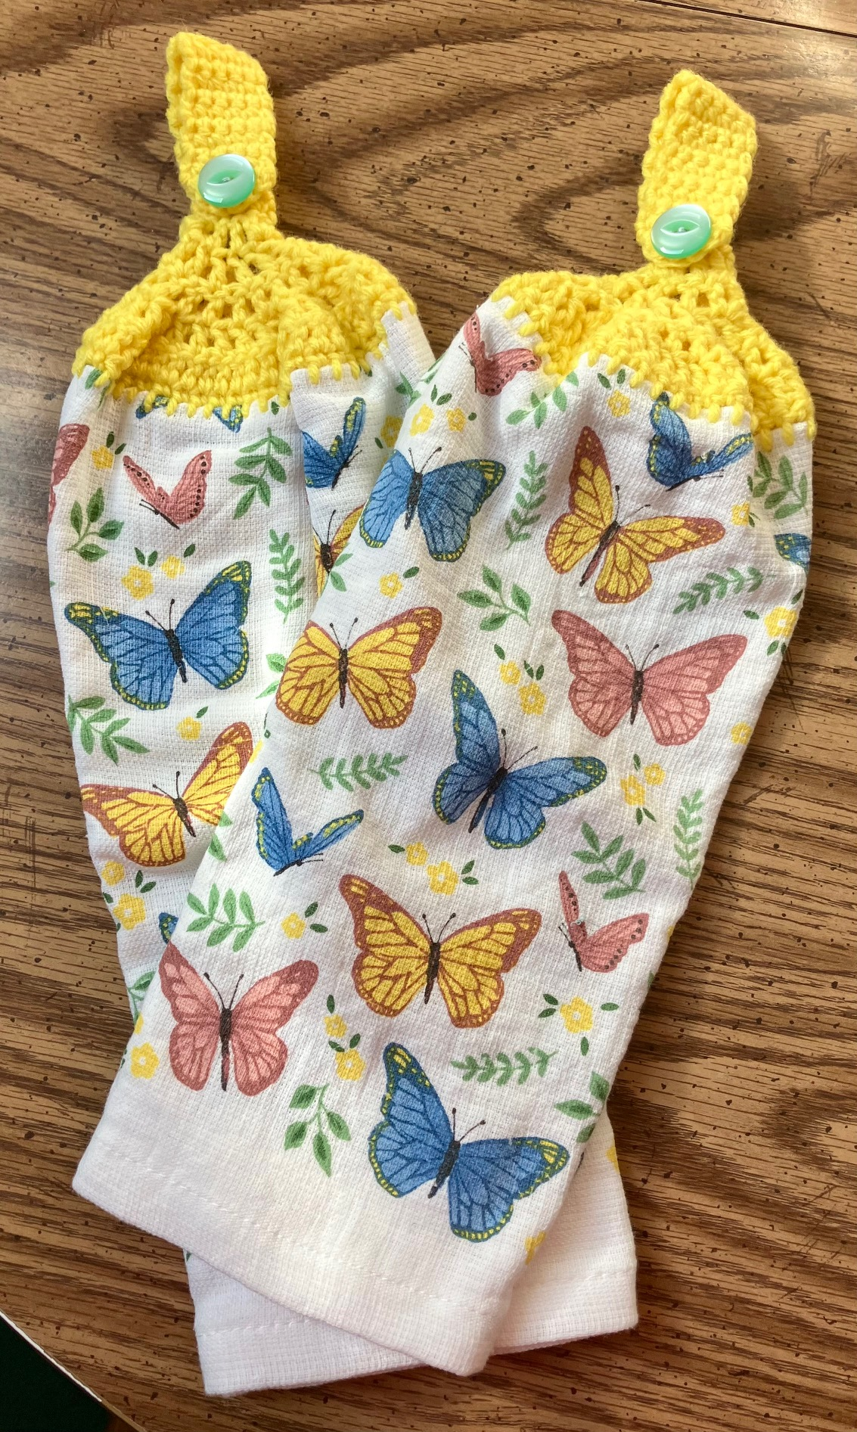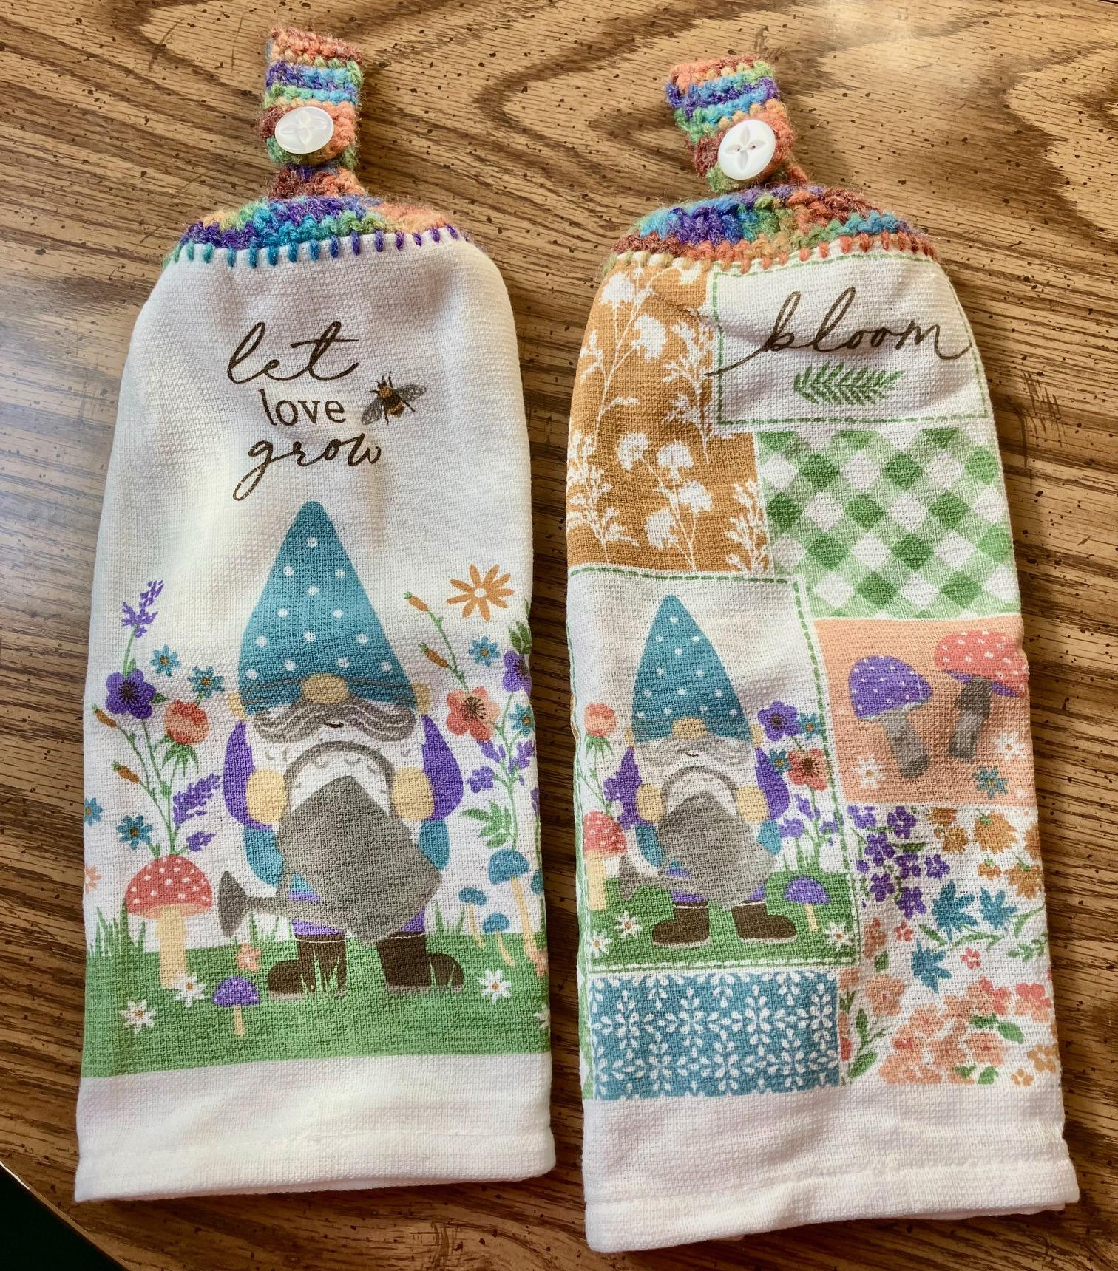

Page 5 of 5

Items For Sale Continued

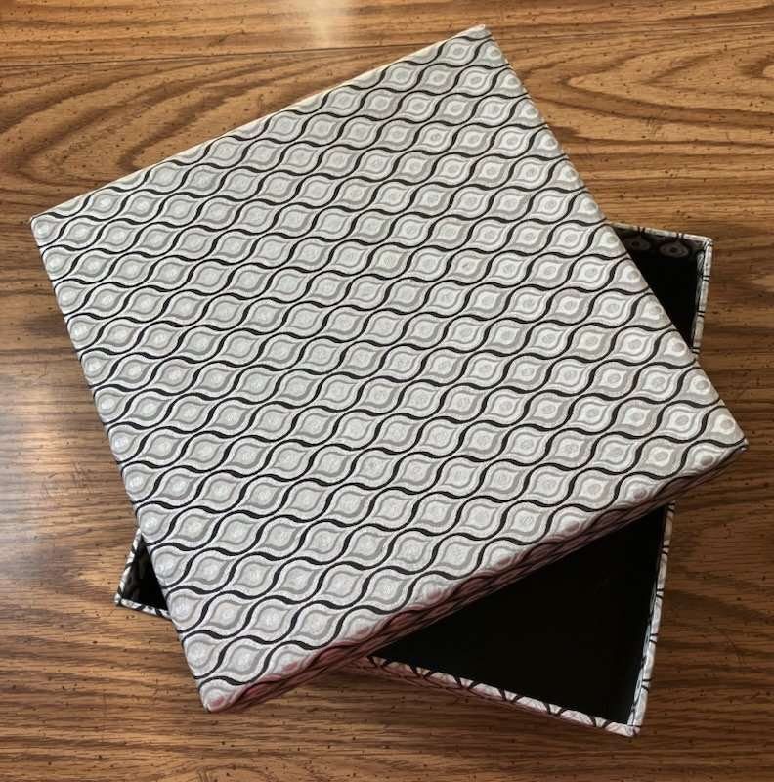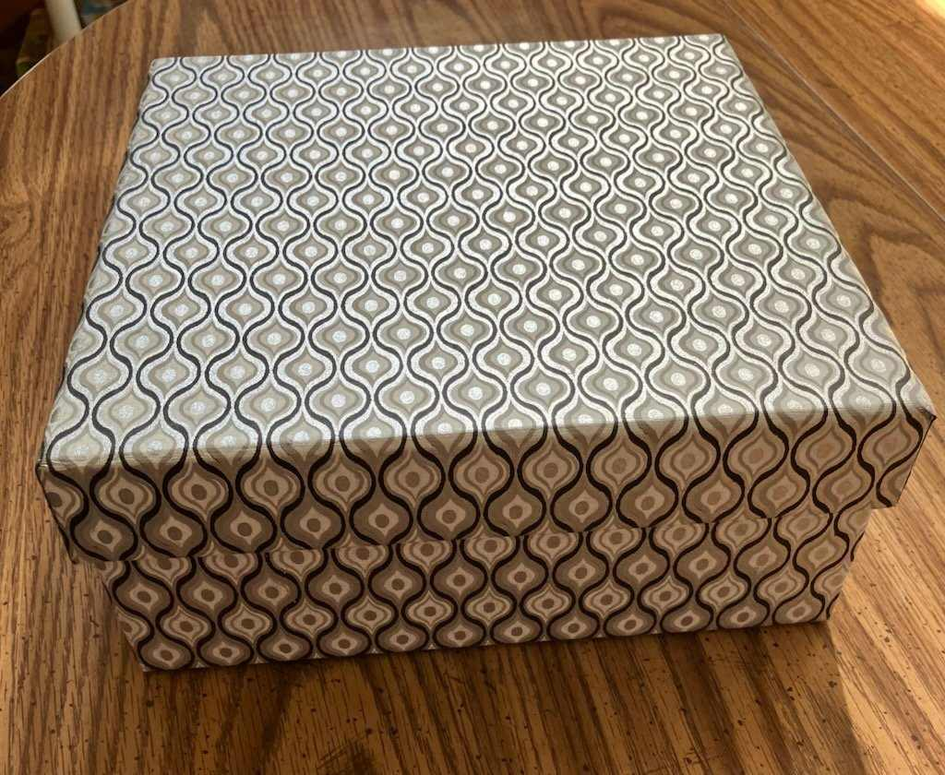
Sturdy, reusable Gift Box of metallic silver, black and white geometric decor. Sold separately or as a gift box or towels. $5.
Randy Wagner: (614) 581-3054
email: sunrands@gmail.com

Sturdy, reusable Gift Box of metallic silver, black and white geometric decor. Sold separately or as a gift box or towels. $5
Sturdy, reusable Gift Box of metallic silver, black and white geometric decor. Sold separately or as a gift box or towels. $5

